**ASSIST/UNA: A Windows-Based Emulator**

**of the ASSIST/I Assembler for the IBM/360**

Software Requirements Specification

Version 1.1.1

February 18, 2014

Travis Hunt, *Team Leader*

Michael Beaver, *Technical Writer*

Andrew Hamilton, *Software Quality Assurance*

Drew Aaron

Clay Boren

Chad Farley

University of North Alabama

CS 455: Software Engineering

Dr. Patricia L. Roden

Spring 2014

# Version History

|  |  |  |  |
| --- | --- | --- | --- |
| **Date** | **Version Number** | **Author(s)** | **Comments** |
| 02/05/2014 | Version 1.0.0 | Michael Beaver | Initial draft |
| 02/06/2014 | Version 1.0.1 | Michael Beaver | Added definitions, acronyms, and abbreviations;  Added project scope;  Added references;  Added user characteristics;  Added change management process; Added assembly instructions appendix;  Removed unnecessary sections |
| 02/07/2014 | Version 1.0.2 | Michael Beaver | Added product perspective;  Added product functions;  Added assumptions and dependencies;  Added functional requirements;  Added use cases;  Added design constraints;  Added other requirements;  Added diagrams to appendix;  Added prototype screen captures;  Updated definitions, acronyms, and abbreviations;  Updated references;  Removed unnecessary sections |
| 02/08/2014 | Version 1.0.3 | Michael Beaver | Added introductory overview;  Added general constraints;  Added external interface requirements;  Added classes/objects;  Added future features appendix;  Updated references;  Updated assembly instructions appendix |
| 02/13/2014 | Version 1.0.4 | Michael Beaver | Updated the introduction;  Updated the general description;  Updated definitions, acronyms, and abbreviations;  Updated user characteristics;  Updated specific requirements;  Updated appendices |
| 02/14/2014 | Version 1.0.5 | Michael Beaver | Updated purpose;  Updated definitions, acronyms, and abbreviations;  Updated user characteristics;  Updated specific requirements;  Updated functional requirements;  Updated non-functional requirements;  Updated deliverables;  Updated appendices;  General editing |
| 02/16/2014 | Version 1.1.0 | Michael Beaver | Updated definitions, acronyms, and abbreviations;  Updated product functions;  Updated user characteristics;  Updated assumptions and dependencies;  Updated external interface requirements;  Updated functional requirements;  Updated use cases;  Updated classes and objects;  General editing |
| 02/18/2014 | Version 1.1.1 | Michael Beaver | Added errors appendix;  Added .PRT appendix;  Added testing;  Updated references |

**TO DO:** *All* the screen captures are out-of-date.

**Table of Contents**

Version History i

1. Introduction 1

1.1 Purpose 1

1.2 Scope 1

1.3 Definitions, Acronyms, and Abbreviations 1

1.4 References 3

1.5 Overview 3

2. General Description 4

2.1 Product Perspective 4

2.2 Product Functions 4

2.3 User Characteristics 4

2.4 General Constraints 4

2.5 Assumptions and Dependencies 5

3. Specific Requirements 5

3.1 External Interface Requirements 5

3.1.1 User Interfaces 5

3.1.2 Software Interfaces 6

3.2 Functional Requirements 6

3.2.1 Source Code Editing 7

3.2.2 Source Code Assembly 7

3.2.3 Source Code Assembly and Debugging 8

3.2.4 Source Code Assembly and Final Run 8

3.2.5 Report Viewing and Printing 9

3.3 Use Cases 9

3.3.1 Create a New Project 9

3.3.2 Save a Project 9

3.3.3 Open a Project 10

3.3.4 Assemble a Program 10

3.3.5 Assemble a Program and Debug 10

3.3.6 Assemble a Program and Perform a Final Run 11

3.3.7 View a .PRT File 11

3.3.8 Print a .PRT File 11

3.3.9 Print Program Source Code 12

3.4 Non-Functional Requirements 12

3.4.1 Performance 12

3.4.2 Reliability 12

3.4.3 Licensing 12

3.4.4 Security 12

3.4.5 Maintainability 13

3.4.6 Portability and Delivery 13

3.5 Design Constraints 13

3.6 Other Requirements 13

4. Testing 13

5. Deliverables 13

6. Change Management Process 14

6.1 Email Report Guidelines 14

7. Client-Developer Contractual Agreement 15

A. Appendices 16

A.1 Assembly Instructions to Implement 16

A.2 The Two-Pass Assembly Process 18

A.3 The .PRT File Format 19

A.4 Assembly Errors 19

A.5 Prototype Graphical User Interface Screen Captures 19

A.6 Features for Future Consideration 24

# 1. Introduction

This document contains all the software requirements and specifications for the ASSIST/UNA software package. The software development team and the client will both sign off and agree to the terms and guarantees listed in this document (see Section 6).

This section provides an overview of what all is contained in this SRS document.

## 1.1 Purpose

The ASSIST/UNA software is primarily designed to enable students to learn and practice the ASSIST assembly language for the IBM/360. The ASSIST/UNA software will replace the current ASSIST/I software emulated with DOSBox. Students and instructors of CS 310 and possibly CS 311 will be using this software.

## 1.2 Scope

The ASSIST/UNA software is a Windows-based emulator of the ASSIST assembly language that will enable students to write assembly programs in a graphical environment. The ASSIST/UNA software will provide students with a subset of the functionality of the ASSIST/I assembler (see Sections 2 and 3). At this time, the ASSIST/UNA software is not meant to *fully* emulate all of the features of the ASSIST/I assembler; however, these features may be implemented later (see Appendix A.4).

The ASSIST/UNA software will be used by students and instructors in future CS 310 and possibly CS 311 courses. This port to the Windows environment eliminates the need to use other emulating software, such as DOSBox, to write assembly programs for the IBM/360. The ASSIST/UNA software will enable students to interact with an emulated ASSIST/I assembler in an intuitive and user-friendly environment.

## 1.3 Definitions, Acronyms, and Abbreviations

This section provides definitions of all terms, acronyms, and abbreviations required to properly interpret this software requirements specification document.

**1.3.1 ASCII:** American Standard Code for Information Interchange character encoding.

**1.3.2** **Assemble:** To translate source statements into corresponding machine code in the form of an object code program.

**1.3.3 Assembler:** A piece of software that assembles assembly source statements.

**1.3.4 ASSIST:** The Assembler System for Student Instruction and Systems Teaching for the IBM/360 developed by John Mashey and his students at Pennsylvania State University.

**1.3.5 ASSIST/I:** The version of ASSIST for personal computers.

**1.3.6 ASSIST/UNA:** The University of North Alabama emulator of the ASSIST/I assembler.

**1.3.7 Backend:**

**1.3.7** **Client:** The person that has instigated development and has decided the project requirements. The current client is Dr. Patricia L. Roden of the University of North Alabama.

**1.3.8 CS 155:** The Computer Science 155: Computer Science I course taught at the University of North Alabama.

**1.3.9 CS 245:** The Computer Science 245: Introduction to Discrete Structures course taught at the University of North Alabama.

**1.3.10 CS 310:** The Computer Science 310: Computer Organization & Assembly Language Programming course taught at the University of North Alabama.

**1.3.11 CS 311:** The Computer Science 311: Computer Architecture course taught at the University of North Alabama.

**1.3.12 Developer:** The person, or persons, who actively design, implement, and maintain the ASSIST/UNA software and the accompanying documentation.

**1.3.13 DOSBox:** A Windows program that emulates the Windows DOS environment.

**1.3.14 EBCDIC:** Extended Binary Coded Decimal Interchange Code character encoding.

**1.3.15 Emulator:** Software on a hardware system that imitates the functionality of other software on its respective hardware system.

**1.3.16 Frontend:**

**1.3.16 GitHub:** A repository service used to store remote copies of project source code and documentation.[1]

**1.3.17 GUI:** Graphical User Interface.

**1.3.18 IBM:** International Business Machines.

**1.3.19 IBM/360:** A family of mainframes designed by IBM.

**1.3.20 IDE:** Integrated Development Environment.

**1.3.21 .NET Framework:** A programming framework developed by Microsoft. This project will be based on the .NET Framework version 4.5.

**1.3.22 .PRT File:** A program report file created by ASSIST/I and ASSIST/UNA software.

**1.3.23 SRS:** Software Requirements Specification document.

**1.3.24 Team Foundation Server (TFS):** A Microsoft Visual Studio version-control system used to maintain and ensure the integrity of project source code.[2]

**1.3.25 UNA:** The University of North Alabama in Florence, Alabama.

**1.3.26 User:** The person, or persons, who interact directly with the ASSIST/UNA software.

**1.3.27 Windows:** The Microsoft Windows operating system environment.

## 1.4 References

This SRS shall be used in conjunction with the following publications and client handouts.

Client, Assembly Instructions to Implement.[3]

Client, Appendix D: Errors and Their Causes.[4]

Client, Initial Project Description.[5]

Client, More Detailed Description.[6]

IEEE Std 830-1998, IEEE Recommended Practice for Software Requirements Specifications.[7]

Microsoft, .NET Framework System Requirements.[8]

## 1.5 Overview

The remainder of this SRS contains the high-level and detailed fundamental requirements of the ASSIST/UNA software. Section 2 provides a general, high-level understanding of the ASSIST/UNA software’s purpose, function, and user characteristics. Section 3 details the fundamental ASSIST/UNA software requirements, including functional requirements, use cases, class/object relationships, and non-functional requirements.

# 2. General Description

The items contained within this section are high-level topics that influence the project and its requirements; these are not the specific requirements. The purpose of this section is to generally describe the requirements and to make the specific requirements easier to comprehend.

## 2.1 Product Perspective

The ASSIST/UNA software is a standalone product. Users of the software will be able to use it without requiring or relying on any outside software.

## 2.2 Product Functions

The main function of the ASSIST/UNA software is to emulate the ASSIST/I assembler with a subset of ASSIST’s instructions. The ASSIST/UNA software will enable users to write and assemble programs from an IDE. Users will also be able to assemble and debug their programs from the ASSIST/UNA environment. Users will also be able to view and print reports and source code directly from the IDE interface.

## 2.3 User Characteristics

The ASSIST/UNA software is to be used by the students and instructors of the CS 310 course and possibly the CS 311 course at UNA. Students should have a basic understanding of programming fundamentals and basic understanding of the ASSIST assembly language. Also, students should have knowledge of binary, hexadecimal, ASCII, and EBCDIC.[9] Although not required, students with experience with IDEs will be benefited. Students lacking experience with IDEs will find the ASSIST/UNA IDE to be intuitive and user-friendly. Instructors should have a strong understanding of the ASSIST assembly language. The ASSIST/UNA IDE will enable instructors to easily open, examine, and test students’ programs. Instructors will also be able to write their own programs.

## 2.4 General Constraints

The ASSIST/UNA software will need to reliably emulate the ASSIST/I assembler, especially since ASSIST/UNA is a teaching tool. This means that processing by and output of ASSIST/UNA must always be accurate. Also, the developers implement the product using the Visual C# programming language and the .NET Framework. Many visual components, such as buttons, are available by default when using Visual Studio. However, the team will inevitably have to create at least one custom component, namely a heavily modified text field.

## 2.5 Assumptions and Dependencies

The ASSIST/UNA software is to be produced for the Microsoft Windows operating system. Since the developers will be using Visual C# and the .NET Framework, only Windows Vista, Windows 7, and Windows 8/8.1 will be supported. The ASSIST/UNA software is being developed for 32-bit and 64-bit versions of the Windows operating system.

# 3. Specific Requirements

The purpose of this section is to give a detailed description of each requirement obtained from the client. Each of these requirements will dictate the development process and design as well as implementation and testing.

## 3.1 External Interface Requirements

This section details the user and software interfaces of the ASSIST/UNA software.

### 3.1.1 User Interfaces

3.1.1.1 Source Code Editor

The Source Code Editor provides a container in which users may write their ASSIST programs. Users may input data by typing into the Source Code Editor or by importing from another source file. The program source code in the Source Code Editor will serve as input to the ASSIST/UNA backend and may also be saved to a file or printed. The Source Code Editor will automatically highlight syntax within the program source code.

3.1.1.2 Registers Display

The Registers Display provides a container in which the assembler’s general-purpose and Program Status Word register contents may be displayed to the user. The registers within the Registers Display are read-only, and the registers do not serve as input to any module. The backend assembler will automatically update the registers within the Register Display. The registers will consist of eight hexadecimal characters. The Program Status Word, a special type of register, will consist of sixteen hexadecimal characters.

3.1.1.3 Memory Display

The Memory Display provides a container in which the assembler’s memory contents may be displayed to the user. The memory content within the Memory Display is read-only, and the memory content does not serve as input to any module. The backend assembler will automatically update the Memory Display. The Memory Display will have the following format: Address; Memory Contents; and, EBCDIC Representation.

3.1.1.4 Symbol Table Display

The Symbol Table Display provides a container in which the assembler’s symbol table content may be displayed to the user. The symbol table content within the Symbol Table Display is read-only, and the symbol table content does not serve as input to any module. The backend assembler will automatically update the Symbol Table Display. The Symbol Table Display will have the following format: Label; and, Address.

3.1.1.5 Output Dialog Window

The Output Dialog Window provides a container in which an assembled program’s output and errors may be displayed to the user. The program’s output and errors within the Output Dialog Window are read-only, and the program’s output and errors are also used to generate the .PRT file. The backend assembler will automatically update the Output Dialog Window.

### 3.1.2 Software Interfaces

3.1.2.1 Open File Dialog

The Open File Dialog enables the user to open source files for editing from within the ASSIST/UNA IDE. The user may open the Open File Dialog by selecting the corresponding menu or toolbar option. The contents of the file selected within the Open File Dialog will be imported to the Source Code Editor (see Section 3.1.1.1). The Open File Dialog functionality is enabled by the Windows operating system.

3.1.2.2 Save File Dialog

The Save File Dialog enables the user to save source files from within the ASSIST/UNA IDE. The user may open the Save File Dialog by selecting the corresponding menu or toolbar option. The contents of the Source Code Editor (see Section 3.1.1.1) will be saved to the user-specified file. The Save File Dialog functionality is enabled by the Windows operating system.

3.1.2.3 Print Dialog

The Print Dialog enables the user print program source code or .PRT files from within the ASSIST/UNA IDE. The user may open the Print Dialog by selecting the respective menu or toolbar option. The contents of the Source Code Editor (see Section 3.1.1.1) will be printed in portrait mode. The contents of the .PRT file will be printed in landscape mode. The Print Dialog functionality is enabled by the Windows operating system.

3.1.2.4 Import Dialog

The Import Dialog enables the user to import source files for editing from within the ASSIST/UNA IDE. The user may open the Import Dialog by selecting the corresponding menu or toolbar option. The contents of the file selected within the Import Dialog will be imported to the Source Code Editor (see Section 3.1.1.1). The Import Dialog functionality is enabled by the Windows operating system.

3.1.2.5 Export Dialog

The Export Dialog enables the user to export source files from within the ASSIST/UNA IDE. The user may open the Export Dialog by selecting the corresponding menu or toolbar option. The contents of the Source Code Editor (see Section 3.1.1.1) will be exported to the user-specified file. The Export Dialog functionality is enabled by the Windows operating system.

## 3.2 Functional Requirements

This section details the fundamental functional requirements of the ASSIST/UNA software.

### 3.2.1 Source Code Editing

3.2.1.1 Introduction

The ASSIST/UNA software shall enable users to write and edit their assembly program source code within the IDE. Users will also have the ability to save their work or open previous work. The users will be able to print their source code from the IDE. Users shall also have access to basic functionality, such as copy, cut, and paste. In addition, users shall be able to perform search and search and replace queries.

3.2.1.2 Inputs

Users will either type their program source code directly or open a file containing the program source code. Files will be automatically imported into the Source Code Editor.

3.2.1.3 Processing

All program source code entered will be forced to uppercase characters. The Source Code Editor will apply syntax highlighting to the program source code. The exact syntax color scheme will be decided at a later date. Users will be able to assemble their program source code. In addition, users will have the option to debug assembled programs.

3.2.1.4 Outputs

Program source code may be saved to a file or printed.

3.2.1.5 Error Handling

The user will be notified via message box if any Source Code Editor errors are encountered.

### 3.2.2 Source Code Assembly

3.2.2.1 Introduction

The ASSIST/UNA software shall enable users to assemble program source code from the IDE’s Source Code Editor.

3.2.2.2 Inputs

Input to the assembler shall be taken directly from the IDE’s Source Code Editor.

3.2.2.3 Processing

The backend system shall parse and process the program source code passed to the assembler. The assembler will update registers, memory content, and the symbol table as the program source code is assembled.

3.2.2.4 Outputs

Upon successful assembly of the program source code, the assembler shall generate and save a .PRT file.

3.2.2.5 Error Handling

Errors encountered during assembly shall be displayed to the user via the Output Dialog Window and reported in the .PRT file.

### 3.2.3 Source Code Assembly and Debugging

3.2.3.1 Introduction

The ASSIST/UNA software shall enable users to assemble program source code from the IDE’s Source Code Editor and to debug the assembled program.

3.2.3.2 Inputs

Input to the assembler shall be taken directly from the IDE’s Source Code Editor.

3.2.3.3 Processing

The backend system shall parse and process the program source code passed to the assembler. The assembler will update registers, memory content, and the symbol table as the program source code is assembled and as program statements are executed. Users shall have the ability to execute one program statement at a time.

3.2.3.4 Outputs

The contents of registers, memory, and the symbol table will be updated and displayed to the user (via the appropriate IDE components) after each program statement is executed. Any output from the program (e.g., XPRNT) shall be displayed in the Output Dialog Window. A .PRT file will not be saved.

3.2.3.5 Error Handling

Errors encountered during assembly shall be displayed to the user via the Output Dialog Window.

### 3.2.4 Source Code Assembly and Final Run

3.2.4.1 Introduction

The ASSIST/UNA software shall enable users to assemble program source code from the IDE’s Source Code Editor and to perform a final run.

3.2.4.2 Inputs

Input to the assembler shall be taken directly from the IDE’s Source Code Editor.

3.2.4.3 Processing

The backend system shall parse and process the program source code passed to the assembler. The assembler will update registers, memory content, and the symbol table as the program source code is assembled. Upon successful assembly, the assembler will execute the program without pausing, unless user input is required.

3.2.4.4 Outputs

The contents of registers, memory, and the symbol table will be updated and displayed to the user (via the appropriate IDE components) during program execution. Upon successful program source code assembly and program termination, the assembler shall generate and save a .PRT file. Any program output (e.g., XPRNT) shall be displayed to the user via the Output Dialog Window.

3.2.4.5 Error Handling

Errors encountered during assembly shall be displayed to the user via the Output Dialog Window and reported in the .PRT file.

### 3.2.5 Report Viewing and Printing

3.2.5.1 Introduction

Users shall be able to view and print .PRT files.

3.2.5.2 Inputs

Users shall select either the view or print option from the IDE interface.

3.2.5.3 Processing

The .PRT file contents, if the file exists and is not empty, shall be displayed to the user in portrait mode in a separate viewing window. The .PRT file shall be printed in landscape mode. The Windows operating system shall handle the printing process.

3.2.5.4 Outputs

The .PRT file shall be displayed in a window or printed.

3.2.5.5 Error Handling

Errors encountered during assembly shall be displayed to the user via the Output Dialog Window.

## 3.3 Use Cases

This section details the fundamental use cases of the ASSIST/UNA software.

### 3.3.1 Create a New Project

3.3.1.1 Description

The user creates a new working project to develop an assembly program.

3.3.1.2 Postconditions

The ASSIST/UNA IDE is reset to enable editing of a new, blank program.

3.3.1.3 Basic Flow

1. The user selects the option to create a new project.

2. The IDE Source Code Editor’s contents are cleared.

3. The registers are reinitialized to the F4F4F4F4 default value.

4. The memory content is reinitialized to the F5F5F5F5 default value.

5. The symbol table’s contents are cleared.

6. The user writes and edits the new source program code.

### 3.3.2 Save a Project

3.3.2.1 Description

The user saves a working project to a source file within the Windows file system.

3.3.2.2 Postconditions

The source program code is saved to a user-specified file.

3.3.2.3 Basic Flow

1. The user selects the option to save a project.

2. The user is prompted to name the source file and the save location.

3. The contents of the Source Code Editor are saved to the user-specified source file.

### 3.3.3 Open a Project

3.3.3.1 Description

The user opens a project to edit.

3.3.3.2 Postconditions

The ASSIST/UNA IDE is reset and the opened source file’s code is loaded into the Source Code Editor.

3.3.3.3 Basic Flow

1. The user selects the option to open a project.

2. The user specifies the source file to be opened.

3. The contents of the source file are imported to the Source Code Editor.

4. The registers are reinitialized to the F4F4F4F4 default value.

5. The memory content is reinitialized to the F5F5F5F5 default value.

6. The symbol table’s contents are cleared.

7. The user writes and edits the program source code.

### 3.3.4 Assemble a Program

3.3.4.1 Description

The user assembles the program source code.

3.3.4.2 Postconditions

The assembled program’s object code is saved. A .PRT file is saved. Errors encountered are reported in the .PRT file and in the Output Dialog Window.

3.3.4.3 Basic Flow

1. The user selects the option to assemble the program source code.

2. The backend assembler assembles the program source code.

3. The assembled program’s object code is saved.

4. A .PRT file is saved.

5. Errors are reported in the .PRT file and in the Output Dialog Window.

### 3.3.5 Assemble a Program and Debug

3.3.5.1 Description

The user assembles and debugs the program source code.

3.3.5.2 Postconditions

The assembled program’s object code is saved. Errors encountered are reported in the Output Dialog Window. No .PRT file is saved.

3.3.5.3 Basic Flow

1. The user selects the option to assemble and debug the program source code.

2. The backend assembler assembles the program source code.

3. The assembled program’s object code is saved.

4. Errors are reported in the Output Dialog Window.

5. The user executes one program statement at a time until program termination.

6. Program output is displayed in the Output Dialog Window.

### 3.3.6 Assemble a Program and Perform a Final Run

3.3.6.1 Description

The user assembles the program source code and performs a final run.

3.3.6.2 Postconditions

The assembled program’s object code is saved. Errors encountered are reported in the .PRT file and the Output Dialog Window. A .PRT file is saved.

3.3.6.3 Basic Flow

1. The user selects the option to assemble the program source code and perform a final run.

2. The user specifies the final run identifier (usually the user’s name).

3. The backend assembler assembles the program source code.

4. The assembled program’s object code is saved.

5. Errors are reported in the Output Dialog Window.

6. The assembled program executes.

7. A .PRT file, including errors, is generated and saved.

8. Program output is displayed in the Output Dialog Window.

### 3.3.7 View a .PRT File

3.3.7.1 Description

The user views a .PRT file for an assembled program.

3.3.7.2 Postconditions

The .PRT file is displayed in a viewing window.

3.3.7.3 Basic Flow

1. The user selects the option to view the .PRT file.

2. If the .PRT file exists, it is displayed in portrait mode in a viewing window.

3. If the .PRT file does not exist, the user is notified accordingly.

### 3.3.8 Print a .PRT File

3.3.8.1 Description

The user prints a .PRT file for an assembled program.

3.3.8.2 Postconditions

The printing of the .PRT file is handled by the Windows operating system.

3.3.8.3 Basic Flow

1. The user selects the option to print the .PRT file.

2. If the .PRT file exists, it is printed in landscape mode (via the Windows operating system).

3. If the .PRT file does not exist, the user is notified accordingly.

### 3.3.9 Print Program Source Code

3.3.9.1 Description

The user prints the program source code.

3.3.9.2 Postconditions

The printing of the program source code is handled by the Windows operating system.

3.3.9.3 Basic Flow

1. The user selects the option to print the program source code.

2. The program source code is printed in portrait mode (via the Windows operating system).

## 3.4 Non-Functional Requirements

This section contains the high-level descriptions of the non-functional requirements of the ASSIST/UNA software.

### 3.4.1 Performance

To facilitate run-time execution efficiency, certain memory size constraints may be instituted. These constraints will be documented in the user’s manual and the ASSIST/UNA source code.

### 3.4.2 Reliability

The ASSIST/UNA software has no tolerance for program crashes. However, in the event of extensive user errors, the ASSIST/UNA software will gracefully shut down. In this case, the user will be notified of the shutdown and the ASSIST/UNA software will attempt to gracefully recover from the error(s).

### 3.4.3 Licensing

The UNA Computer Science and Information Systems Department will retain full rights to the ASSIST/UNA software upon delivery. The ASSIST/UNA source code will not be freely open to all persons but will be made available to future classes as necessary.

### 3.4.4 Security

There are no security concerns for the ASSIST/UNA software.

### 3.4.5 Maintainability

Upon delivery of the ASSIST/UNA software, the current development team shall be relinquished of all maintenance responsibilities. If the ASSIST/UNA software requires maintenance, the task shall be given to future classes. The client reserves the right to contact the current developers for courtesy consultations; however, current developers reserve the right to decline if necessary.

### 3.4.6 Portability and Delivery

The ASSIST/UNA software will be made as portable as possible for ease of delivery and use. The actual delivery method will be negotiated with the client after this document has been approved by both the developers and the client.

## 3.5 Design Constraints

Test cases involving source program code cannot be published publicly to GitHub. One of the developers is currently enrolled in CS 310 and cannot be allowed an unfair advantage. As such, he will be delegated to a primary role in frontend interface testing.

Since the chosen .NET Framework is supported only on Windows Vista, Windows 7, and Windows 8/8.1, the ASSIST/UNA software will not necessarily be portable to other operating systems.

In an effort to increase run-time execution efficiency, certain backend components will need to be limited. For example, to save on the amount of memory allocated, the symbol table may be limited to a certain number of labels. Any such limitations will be documented in the user’s manual and ASSIST/UNA source code.

## 3.6 Other Requirements

Users shall be able to modify the assembler options found in the original ASSIST/I via an options menu provided by ASSIST/UNA. These options include: Saving the output; changing the maximum number of output lines; changing the maximum number of program instructions; changing the maximum number of program pages; and, changing the maximum program size (in bytes). Users also shall not be restricted to one working directory. That is, users shall be able to specify absolute and relative paths to data files for assembled programs.

# 4. Testing

…

# 5. Deliverables

The development team shall deliver project documents on April 29, 2014, in addition to providing a presentation for the client and other guests. The team shall deliver the following printed documents: The ASSIST/UNA source code; team emails; meeting minutes; project designs; the SRS; client questions and answers; the user’s manual; test files; and, test data. In addition, the team will deliver a digital copy of the user’s manual. The team will also present a method for the client to effectively and appropriately present the ASSIST/UNA software to future students.

# 6. Change Management Process

Before reporting a change or an error, developers must ensure they are consulting the most recent version of the software requirements specification document. If a change is required or an error is encountered, the SRS will be amended upon negotiation and approval by the client. Developers shall notify the technical writer and the team leader via email. The email will detail the section(s) and line number(s) that need to be modified. In addition, the email will contain detailed descriptions of each change or error. The reporting developer shall also provide a detailed suggested correction. The technical writer will review the correction reports, approve the corrections, and update this document as necessary. The new version of this document shall be uploaded to the GitHub repository.

## 6.1 Email Report Guidelines

If a developer needs to report changes or errors in the SRS, he shall follow these guidelines:

* The email will be sent to the technical writer and the team leader.
* The email subject will read: “CS 455 – Spec Doc Changes.”
* The email will specify the version of the SRS being reviewed.
* The email will contain the following sections for each change or error:
  + Section Number
  + Line Number
  + Detailed description of the change or error
  + Detailed suggested correction
* Developers should send themselves a carbon copy for their own records.

Each section of the email should be appropriately labeled. For example, the “Section Number(s)” section should be labeled “**Section Number(s)**” (note the boldface). Also note that each reported change or error will need its own set of the aforementioned sections (with appropriate labels).

# 7. Client-Developer Contractual Agreement

The client (Dr. Patricia L. Roden) is satisfied that this SRS meets the project requirements as specified at this time. The developers (listed below) recognize the client’s right to request modifications of the project requirements. The client will ensure the modifications are necessary and will notify the developers at least one week in advance. The client hereby approves this SRS in its current form. The developers agree thusly to deliver the agreed upon deliverables on April 29, 2014.

The client agrees to fairly assess the work delivered by the developers, in accordance with the specified requirements within this document. Additionally, the client agrees to assign to each developer the appropriate grade mark for his individual and overall contributions to the project. While grading the overall work, the client agrees to consult each developer’s evaluations.

The signatures below hereby bind the client and the developers to this contractual agreement.

*Dr. Patricia L. Roden, Client* Date

*Travis Hunt, Team Leader* Date

*Michael Beaver, Technical Writer* Date

*Andrew Hamilton, Software Quality Assurance*  Date

*Drew Aaron* Date

*Clay Boren* Date

*Chad Farley* Date

# A. Appendices

Supplemental tables, figures, and miscellaneous information may be found within this appendix. The first section contains a list of ASSIST instruction types and the list of required instructions to be implemented. The second section contains initial high-level frontend and backend diagrams. The third section contains screen captures of the prototype. The final section contains features that may not be implemented due to time constraints but may be desired by the client at a later time.

## A.1 Assembly Instructions to Implement

This appendix contains the list of required ASSIST assembly instructions to be implemented in the ASSIST/UNA emulator. Table A.1.1 lists the types of instructions supported by ASSIST/UNA. Table A.1.2 lists each instruction’s mnemonic, description, instruction type, and basic form.

Table A.1.1: ASSIST instruction types supported by ASSIST/UNA.

|  |  |
| --- | --- |
| **Type** | **Type Description** |
| RR | Register-Register. Operands are taken from registers, manipulated, and the result is stored into the first operand’s register (e.g., AR 3,4). |
| RS | Register-Storage. The first operand is in a register, and the second operand is in main storage. Memory contents are accessed by D(B) addressing (e.g., LM 4,6,12(13)). |
| RX | Register-Storage. The first operand is in a register, and the second operand is in main storage. Memory contents are accessed by D(X,B) addressing (e.g., LA 11,10(3,9)). |
| SI | Storage-Immediate. The first operand is in main storage, and the second operand is an eight-bit (one byte) *immediate* operand. Memory contents are accessed by D(B) addressing (e.g., CLI 0(20),C’a’). |
| SS | Storage-Storage. Both operands are in main storage. Memory contents are accessed using D(B) addressing. Often a length L is specified (e.g., MVC 0(5,3),0(2)). |
| X* | An instruction whose mnemonic is preceded by an “X” is a special macro instruction that actually comprises several instructions. Memory contents are accessed using D(X,B) addressing (e.g., XDECI 3,0(1)). |

Table A.1.2: ASSIST/I Instructions to be implemented.

|  |  |  |  |
| --- | --- | --- | --- |
| **Mnemonic** | **Description** | **Type** | **Basic Form** |
| A | Add | RX | A R1,D2(X2,B2) |
| AP | Add Packed | SS | AP D1(L1,B1),D2(L2,B2) |
| AR | Add Register | RR | AR R1,R2 |
| BAL | Branch and Link | RX | BAL R1,D2(X2,B2) |
| BALR | Branch and Link Register | RR | BALR R1,R2 |
| BC | Branch on Condition | RX | BC B’mask’,D2(X2,B2) |
| BCR | Branch on Condition Register | RR | BCR B’mask’,R2 |
| BCT | Branch on Count | RX | BCT R1,D2(X2,B2) |
| BCTR | Branch on Count Register | RR | BCTR R1,R2 |
| BXH | Branch on Index High | RS | BXH R1,R2,D3(B3) |
| BXLE | Branch on Index Low or Equal | RS | BXLE R1,R2,D3(B3) |
| C | Compare | RX | C R1,D2(X2,B2) |
| CLC | Compare Logical Characters | SS | CLC D1(L1,B1),D2(B2) |
| CLI | Compare Logical Immediate | SI | CLI D1(B1),I2 |
| CP | Compare Packed | SS | CP D1(L1,B1),D2(L2,B2) |
| CR | Compare Register | RR | CR R1,R2 |
| D | Divide | RX | D R1,D2(X2,B2) |
| DP | Divide Packed | SS | DP D1(L1,B1),D2(L2,B2) |
| DR | Divide Register | RR | DR R1,R2 |
| ED | Edit | SS | ED D1(L1,B1),D2(B2) |
| EDMK | Edit and Mark | SS | EDMK D1(L1,B1),D2(B2) |
| L | Load | RX | L R1,D2(X2,B2) |
| LA | Load Address | RX | LA R1,D2(X2,B2) |
| LM | Load Multiple | RS | LM R1,R2,D3(B3) |
| LR | Load Register | RR | LR R1,R2 |
| M | Multiply | RX | M R1,D2(X2,B2) |
| MP | Multiply Packed | SS | MP D1(L1,B1),D2(L2,B2) |
| MR | Multiply Register | RR | MR R1,R2 |
| MVC | Move Characters | SS | MVC D1(L1,B1),D2(B2) |
| MVI | Move Immediate | SI | MVI D1(B1),I2 |
| N | Bitwise AND | RX | N R1,D2(X2,B2) |
| NR | Bitwise AND Register | RR | NR R1,R2 |
| O | Bitwise OR | RX | O R1,D2(X2,B2) |
| OR | Bitwise OR Register | RR | OR R1,R2 |
| PACK | Pack | SS | PACK D1(L1,B1),D2(L2,B2) |
| S | Subtract | RX | S R1,D2(X2,B2) |
| SP | Subtract Packed | SS | SP D1(L1,B1),D2(L2,B2) |
| SR | Subtract Register | RR | SR R1,R2 |
| ST | Store | RX | ST R1,D2(X2,B2) |
| STM | Store Multiple | RS | STM R1,R2,D3(B3) |
| UNPK | Unpack | SS | UNPK D1(L1,B1),D2(L2,B2) |
| XDECI | Convert Input to Decimal | X* | XDECI R1,D2(X2,B2) |
| XDECO | Convert Output to Decimal | X* | XDECO R1,D2(X2,B2) |
| XPRNT | Print Output | X* | XPRNT D1(X1,B1),L2 |
| XREAD | Read Input | X* | XREAD D1(X1,B1),L2 |
| ZAP | Zero, Add Packed | SS | ZAP D1(L1,B1),D2(L2,B2) |

## A.2 The Two-Pass Assembly Process

This appendix contains a high-level description of the two-pass assembly process. The ASSIST assembler is a two-pass assembler, so the ASSIST/UNA emulator will also be two-pass.

**A.2.1 Pass 1**

1. Maintain the location counter
   1. Make use of the machine operations table (see Appendix A.1)
   2. Process DS and DC statements
      1. Know sizes in bytes
         1. Character = 1 byte
         2. Halfword = 2 bytes
         3. Fullword = 4 bytes
         4. Doubleword = 8 bytes
      2. Enforce boundary alignments
   3. Process literals and create the literal table
2. Construct the symbol table
   1. Anything in columns 1-8 (i.e., labels) and the current location counter are entered into the symbol table
3. *(Design Option)* Create an intermediate file for Pass 2
4. Process assembler directives
   1. START
   2. END
   3. USING
   4. DS and DC
   5. SPACE
   6. TITLE
   7. EJECT

**A.2.2 Pass 2**

In Pass 2, use the intermediate file from Pass 1 or the original source file.

1. Create object code for each line
   1. Use the machine operations table
   2. Use the symbol table
   3. Use the literal table
2. Create a listing line in the .PRT file (see Appendix A.3)
3. Print any errors encountered in Pass 1 or Pass 2
4. Create an object program, which the emulator will execute

## A.3 The .PRT File Format

This appendix contains the basic format of the generated .PRT file. The .PRT file is constituted by source listings (rows) and columns. The columns are the location counter, the object code, the line number, and the source statement. The ASSIST/I .PRT file format has a column for an address; however, this will be omitted for simplicity. Table A.3.1 provides an excerpt of a generated .PRT file.

Table A.3.1: A sample excerpt from a .PRT file.

|  |  |  |  |
| --- | --- | --- | --- |
| LOC | OBJECT CODE | LINE | SOURCE STATEMENT |
| 000000 |  | 1 | MYPROG START |
| 000000 | 90EC D00C | 2 | STM 14,12,12(13) |
| 000004 | 05C0 | 3 | BALR 12,0 |
| 000006 |  | 4 | USING SAVING,12 |
| 000006 | 50D0 C07E | 5 | SAVING ST 13,SAVEAREA+4 |
| 00000A | 41D0 C07A | 6 | LA 13,SAVEAREA |
| ... | ... | ... | ... |
| 000080 |  | 50 | SAVEAREA DS 18F |
|  |  | 51 | END MYPROG |

## A.4 Supported Assembler Errors

This appendix contains basic descriptions of the types of errors that may be encountered during assembly. The following errors are supported: Addressing exception; data exception; decimal-overflow exception; decimal-divide exception; fixed-point overflow exception; fixed-point divide exception; operation exception; protection exception; and, specification exception. Table A.4.1 summarizes which types of errors are possible for each mnemonic (see Appendix A.1).

**A.4.1 Addressing Exception (A)**

An addressing exception occurs when attempting to reference an address outside of actual memory.

**A.4.2 Data Exception (D)**

A data exception is the result of an attempt to manipulate a field that should contain a valid packed-decimal number but does not.

**A.4.3 Decimal-overflow Exception (DO)**

A decimal-overflow exception occurs when the result of a decimal arithmetic instruction cannot be represented in the receiving field.

**A.4.4 Decimal-divide Exception (DD)**

A decimal-divide exception occurs when the quotient from the execution of a DP statement (see Appendix A.1) is too large to be represented in the allotted space or when an attempt is made to divide by zero.

**A.4.5 Fixed-point Overflow Exception (FO)**

A fixed-point overflow exception occurs when the result of an arithmetic operation cannot be represented in a 32-bit word.

**A.4.6 Fixed-point Divide Exception (FD)**

A fixed-point divide exception occurs when the quotient of D or DR (see Appendix A.1) cannot be represented in a 32-bit word. This error also occurs in the event of division by zero.

**A.4.7 Operation Exception**

An operation exception occurs when an attempt is made to execute a memory value that is not a valid instruction. An operation exception can occur if a constant is included in the middle of a routine, if a section of a program is altered during execution, or if a branch address is incorrect.

**A.4.8 Protection Exception (P)**

A protection exception occurs when an executed instruction attempts to access or modify memory outside the limits of the program.

**A.4.9 Specification Exception (S)**

A specification exception occurs when boundary alignment is unobserved or when an unexpected value is encountered in an index register.

Table A.4.1: The assembler errors supported by each mnemonic (see Appendix A.1).

|  |  |  |  |  |  |  |  |  |
| --- | --- | --- | --- | --- | --- | --- | --- | --- |
| **Mnemonic** | **A** | **D** | **DO** | **DD** | **FD** | **FO** | **P** | **S** |
| A | X | -- | -- | -- | X | -- | X | X |
| AP | X | X | X | -- | -- | -- | X | -- |
| AR | -- | -- | -- | -- | X | -- | -- | -- |
| BAL | -- | -- | -- | -- | -- | -- | -- | -- |
| BALR | -- | -- | -- | -- | -- | -- | -- | -- |
| BC | -- | -- | -- | -- | -- | -- | -- | -- |
| BCR | -- | -- | -- | -- | -- | -- | -- | -- |
| BCT | -- | -- | -- | -- | -- | -- | -- | -- |
| BCTR | -- | -- | -- | -- | -- | -- | -- | -- |
| BXH | -- | -- | -- | -- | -- | -- | -- | -- |
| BXLE | -- | -- | -- | -- | -- | -- | -- | -- |
| C | X | -- | -- | -- | -- | -- | X | X |
| CLC | X | -- | -- | -- | -- | -- | X | -- |
| CLI | X | -- | -- | -- | -- | -- | X | -- |
| CP | X | X | -- | -- | -- | -- | X | -- |
| CR | -- | -- | -- | -- | -- | -- | -- | -- |
| D | X | -- | -- | -- | -- | X | X | X |
| DP | X | X | -- | X | -- | -- | X | X |
| DR | -- | -- | -- | -- | -- | X | -- | X |
| ED | X | X | -- | -- | -- | -- | X | -- |
| EDMK | X | X | -- | -- | -- | -- | X | -- |
| L | X | -- | -- | -- | -- | -- | X | X |
| LA | -- | -- | -- | -- | -- | -- | -- | -- |
| LM | X | -- | -- | -- | -- | -- | X | X |
| LR | -- | -- | -- | -- | -- | -- | -- | -- |
| M | X | -- | -- | -- | -- | -- | X | X |
| MP | X | X | -- | -- | -- | -- | X | X |
| MR | -- | -- | -- | -- | -- | -- | -- | X |
| MVC | X | -- | -- | -- | -- | -- | X | -- |
| MVI | X | -- | -- | -- | -- | -- | X | -- |
| N | X | -- | -- | -- | -- | -- | X | X |
| NR | -- | -- | -- | -- | -- | -- | -- | -- |
| O | X | -- | -- | -- | -- | -- | X | X |
| OR | -- | -- | -- | -- | -- | -- | -- | -- |
| PACK | X | -- | -- | -- | -- | -- | X | -- |
| S | X | -- | -- | -- | X | -- | X | X |
| SP | X | X | X | -- | -- | -- | X | -- |
| SR | -- | -- | -- | -- | X | -- | -- | -- |
| ST | X | -- | -- | -- | -- | -- | X | X |
| STM | X | -- | -- | -- | -- | -- | X | X |
| UNPK | X | -- | -- | -- | -- | -- | X | -- |
| ZAP | X | X | X | -- | -- | -- | X | -- |

## A.5 Prototype Graphical User Interface Screen Captures

This appendix contains screen captures of the initial ASSIST/UNA prototype. Note: This prototype is *not* final and is subject to change. It is also worth noting that not all required features in this software requirements specification document are in the initial ASSIST/UNA prototype. This prototype is meant to serve as inspiration and as a point of discussion.

Figure A.5.1: The default IDE state.

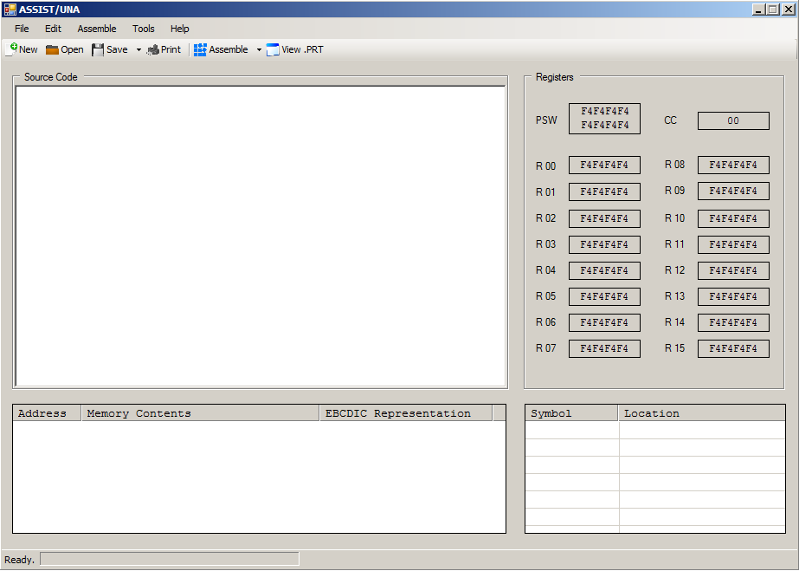

Figure A.5.2: Source program code in the IDE text editor. Note the highlighted comments.

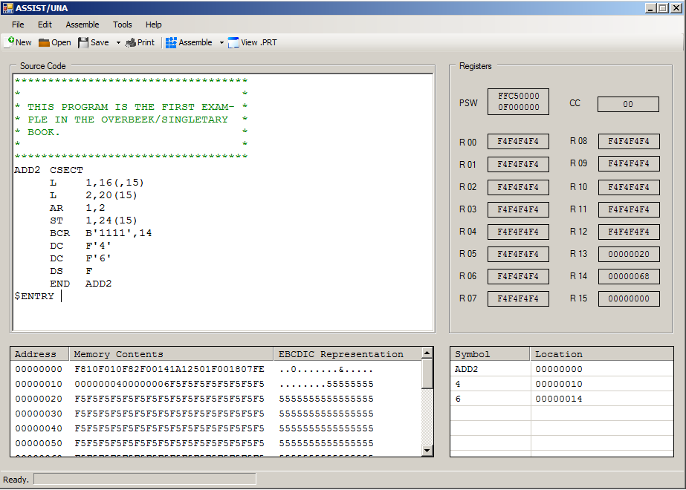

Figure A.5.3: The “File” menu options.

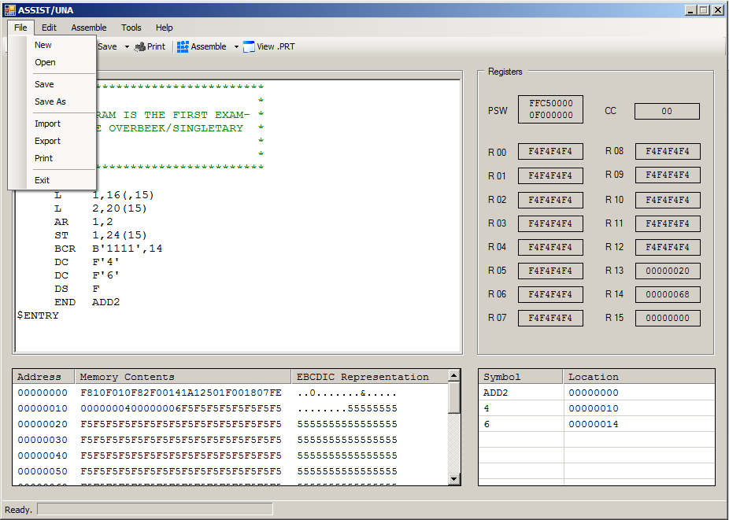

Figure A.5.4: The “Edit” menu options.

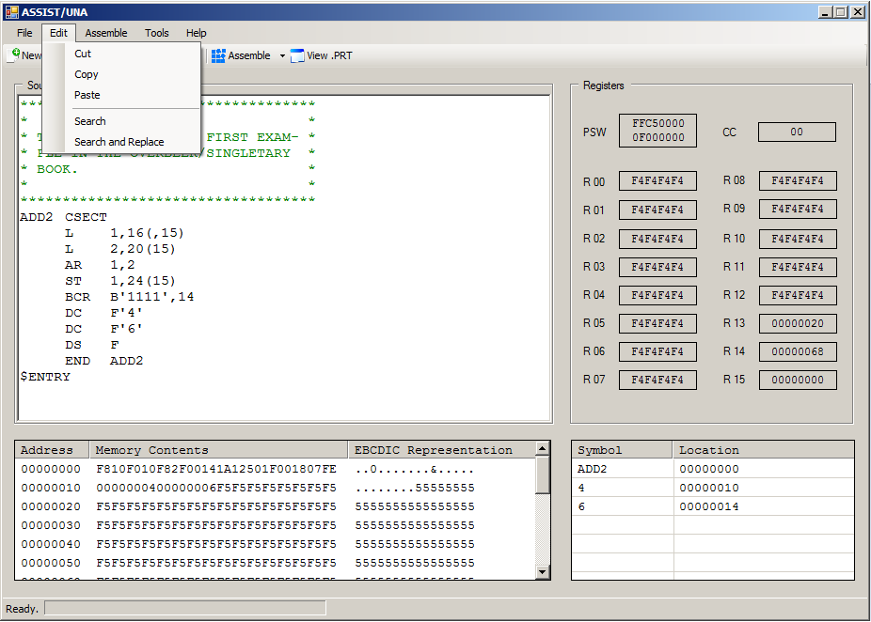

Figure A.5.5: The “Assemble” menu options.

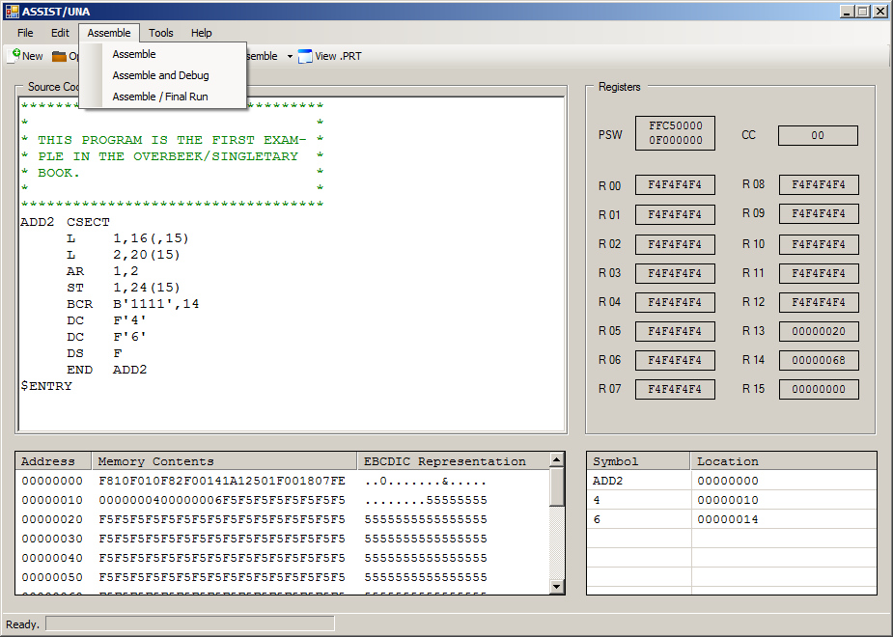

Figure A.5.6: The “Tools” menu options.

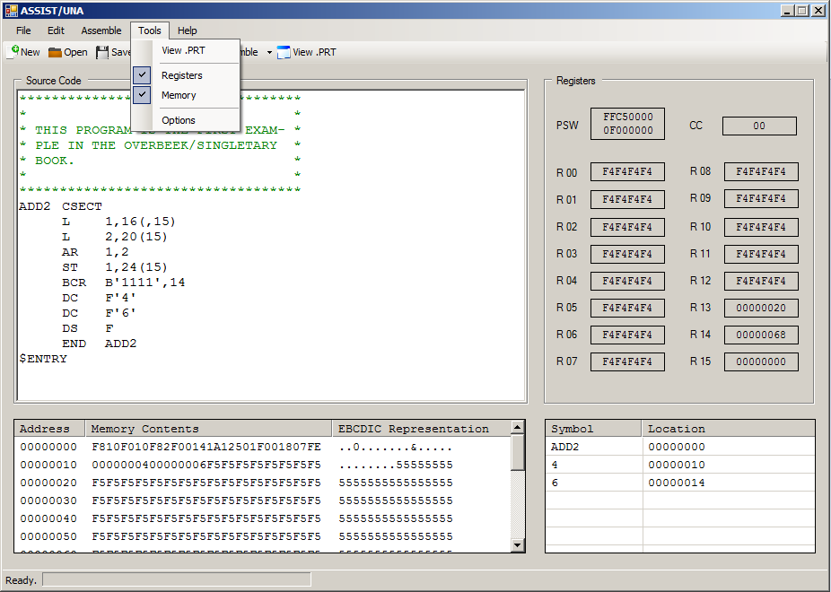

Figure A.5.7: The “Help” menu options.

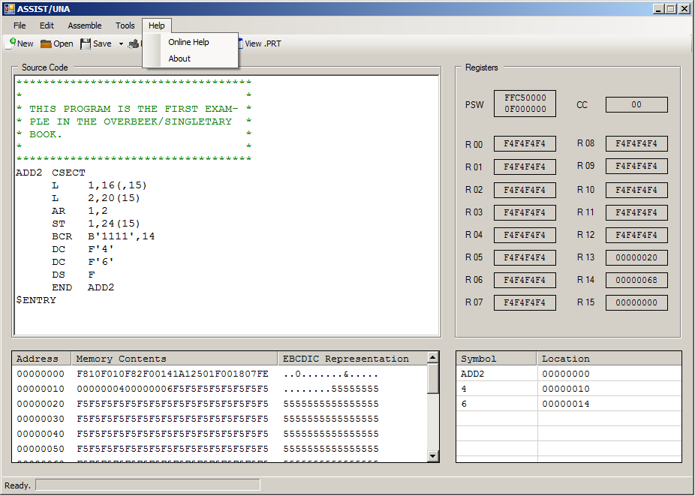

Figure A.5.8: The “Save” toolbar options.

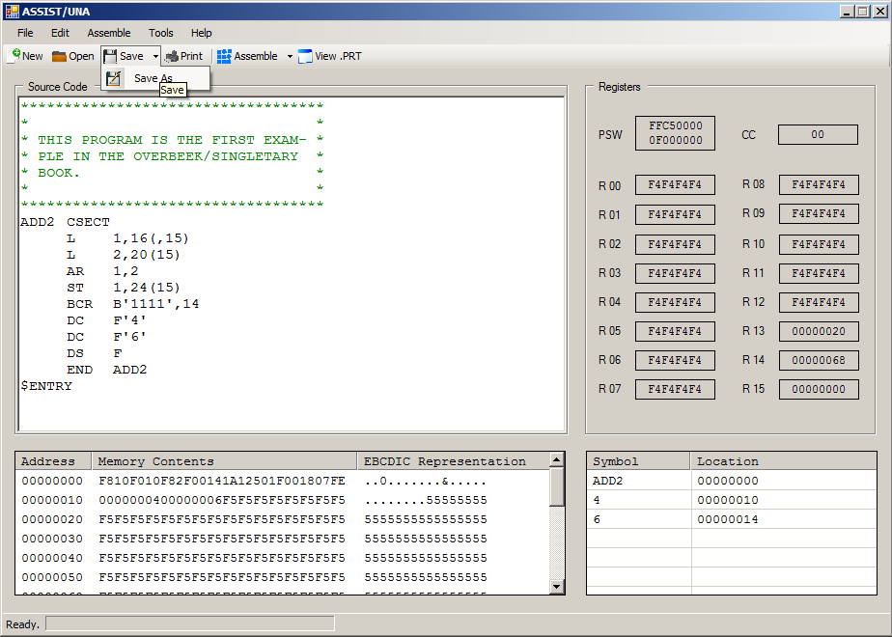

Figure A.5.9: The “Assemble” toolbar options.

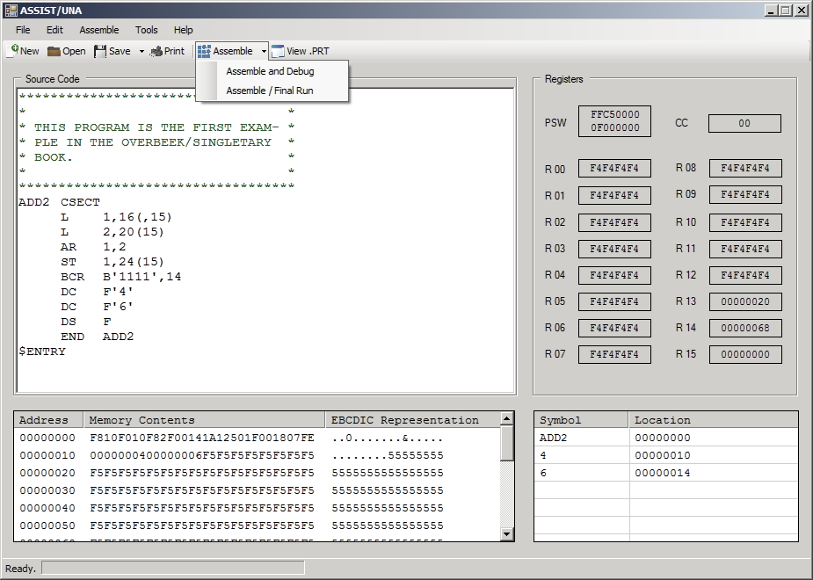

## A.6 Features for Future Consideration

This appendix lists ASSIST/UNA software features that are not required but may be considered for implementation at a later date.

**A.6.1 Formatted Tabs**

When the user presses the tab key in the Source Code Editor (see Section 3.1.1.1), the cursor within the editor moves the appropriate amount of spaces.

**A.6.2 Opcode Completion or Hinting**

When the user begins entering an instruction’s mnemonic, the Source Code Editor (see Section 3.1.1.1) automatically completes the instruction. Alternatively, the user could be presented with a list of potential instruction mnemonics.

**A.6.3 Embedded Calculator**

The user presses a certain shortcut or hotkey to bring up a calculator within the IDE. The calculator should have the ability to calculate with and convert between hexadecimal, decimal, octal, and binary values.

**A.6.4 Disassembly**

The user imports an assembled program that may be disassembled back into its original program source code.

**A.6.5 Reference Asterisk**

The user may use an asterisk within the program source code to refer to the location counter.

**A.6.6 Floating-point Registers**

The ASSIST/UNA assembler should be able to emulate the IBM/360’s four floating-point registers.

**A.6.7 Breakpoints**

The user will be able to set and run to breakpoints in the debugging mode.

1. See http://www.github.com.
2. See http://www.visualstudio.com.
3. Available on ANGEL. See Appendix A.1.
4. Given as a handout.
5. See footnote 1. See Sections 2 and 3.
6. See footnote 1. See Sections 2 and 3.
7. Available at http://standards.ieee.org/findstds/standard/830-1998.html. This IEEE guide is used throughout this software requirements specification document.
8. Available at http://msdn.microsoft.com/en-us/library/8z6watww%28v=vs.110%29.aspx. See Section 2.5.
9. Students should have completed CS 155 and CS 245.